# Custom Widgets

Splash

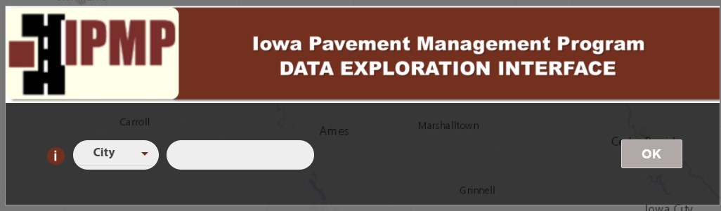

**Overview:**

This is displayed on page load, containing inputs to query the server for specific data. Queries use the library <https://developers.arcgis.com/javascript/latest/api-reference/esri-tasks-QueryTask.html> to request and receive data, based on parameters selected by user. There are three ‘levels’ of queries made by splash:

* On load, makes a query to find unique jurisdictions to display in dropdown
* When data is entered in the input box, makes a query to find available years for the selected jurisdiciton / area
* And finally, on ‘OK’, makes a query to the server for all data for the jurisdiction / year and all available years (but hides the years not selected)

Source: master/widgets/Splash/Widget.js

Visualize Data

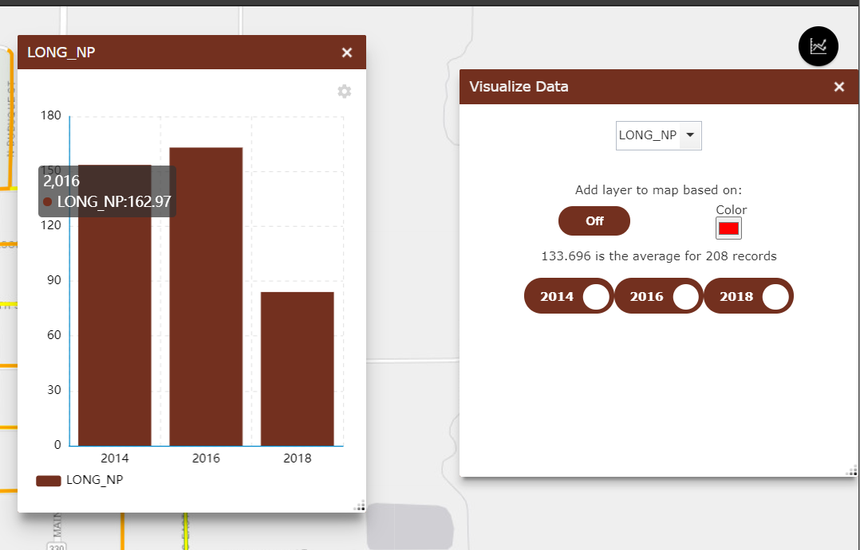

**Overview:**

This widget makes calculations on the provided data to display infographics / visuals on the data:

* Selecting a field from the drop down opens and infographic, which displays the avg value per year for the selected field.
* Adding a layer to map can be based on Min / Max / + change / - change of the data: where each line is compared with the min or max of the dataset (or relative +/- change between previous and current year), and assigned a color. For example, if ‘max’ is selected, and a color is
  + grey: the line has a min / avg value
  + red (or selected color): the line has a max value
* The years show/hide layers from both the map and the current data source used for the infographics and layer calculations.

Source: master/widgets/PickColumns/Widget.js

Treatment

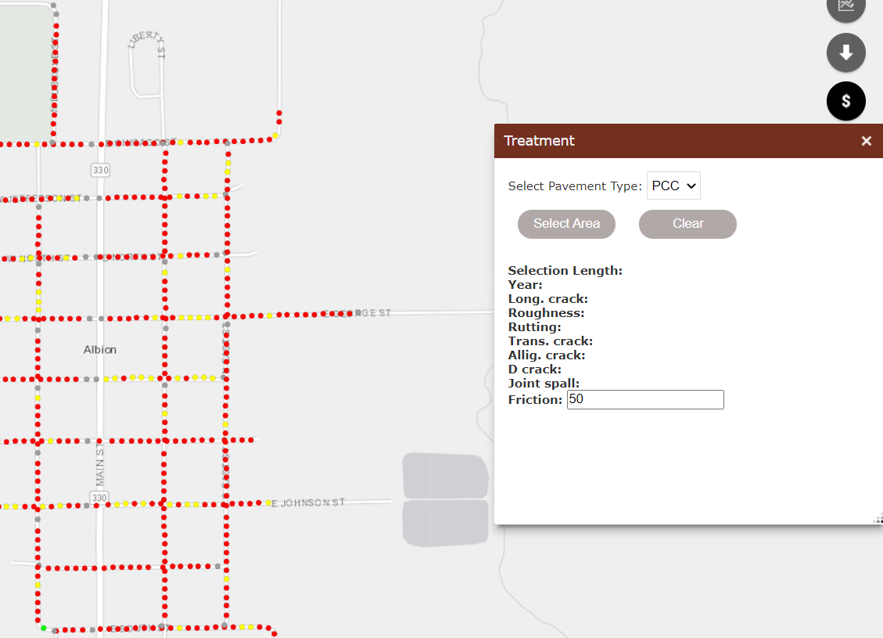

**Overview:**

This widget performs calculations on points to give an estimate of improvements & cost for the given area. Select area defines the set of points of calculate,

Source: master/widgets/Treatment/Widget.js

Download Data

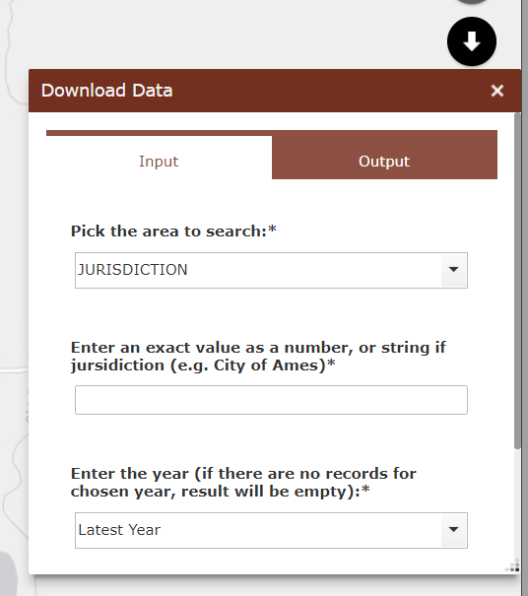

**Overview:**

None of the functionality of this widget is defined locally, but at the server: <https://ipmp.ctre.iastate.edu/arcgis/rest/services/aphares/Download_Oct21/GPServer> (see step-by-step guide). The data selected is not from the web map, but packaged with the geoprocessing service.

Source: <https://ipmp.ctre.iastate.edu/arcgis/rest/services/aphares/Download_Oct21/GPServer>